POSITIVE OR NEGATIVE

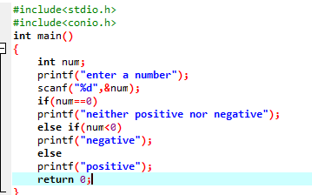

OUTPUT

